**Tutorial 22: Reaction Timer Game – Lifecycle Hooks**

Every Vue component that you create goes through a specific lifecycle in your application. It is created, mounted to the dom or eventually when we don’t need it anymore on the screen it is destroyed. We can access different parts of the lifecycle in a Vue component and run code at different points using a concept called lifecycle hooks.

<https://v3.vuejs.org/api/options-lifecycle-hooks.html#rendertriggered>

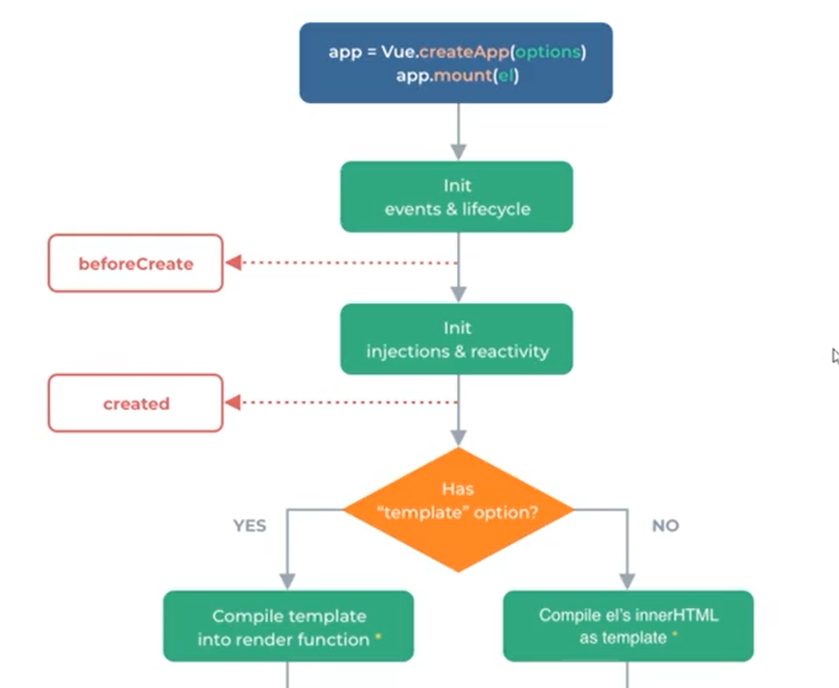

**View Full Lifecycle Hook Diagram:** <https://v3.vuejs.org/guide/instance.html#lifecycle-diagram>

We will be focusing on displaying the block after a few seconds have passed.

Make sure **Tutorial 21** is complete to be able to move on to this tutorial or clone the [vue3-firebase-course](https://github.com/younggrasshopperza/vue3-firebase-course) repository and go to branch called **Tutorial-21**.

**Step 1:** In the **Block.vue** file, create a data property called **showBlock** and assign the value to false. Inside the template in the div with a class called block include a condition that checks whether **showBlock** is true.

Look at the example below (**between line 1 to 13**):

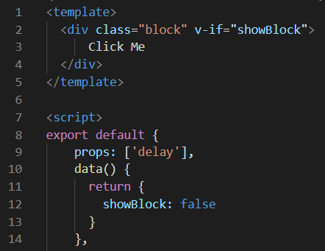

**Step 2:** In the **Block.vue** file, add the Lifecycle Hook mounted. Inside the mounted Lifecycle hook, create a **setTimeout** function that executes when the prop, “delay” is complete, set the **showBlock** value to **true**.

Look at the example below (**between line 16 to 22**):

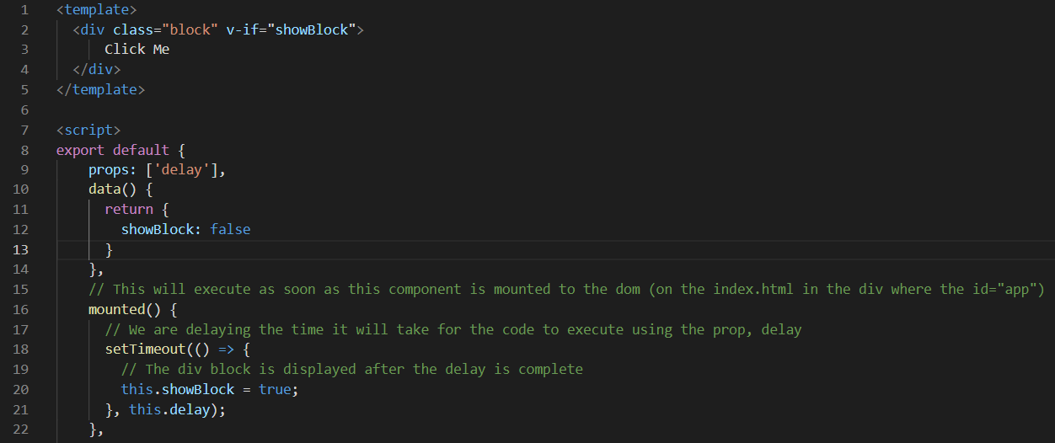

**Step 3:** In the **Block.vue** file, add the Lifecycle Hook updated and console log the text, “**component updated**”. The text will be outputted as soon as the **showBlock** updates to true.

Look at the example below (**between line 24 to 26**):

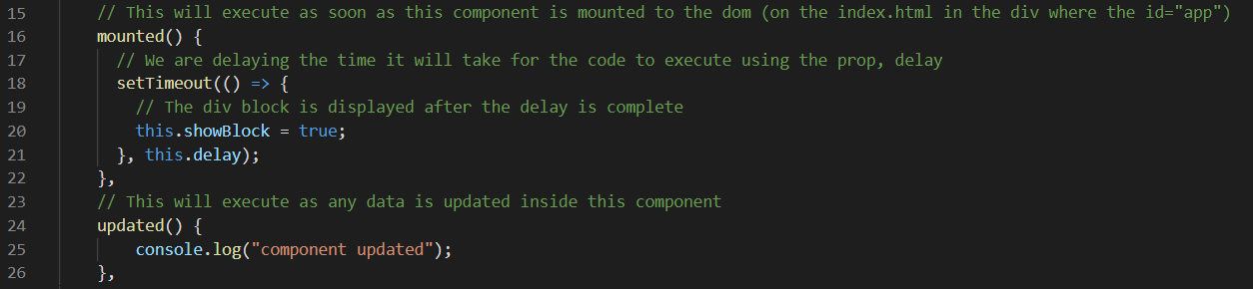

**Output:**

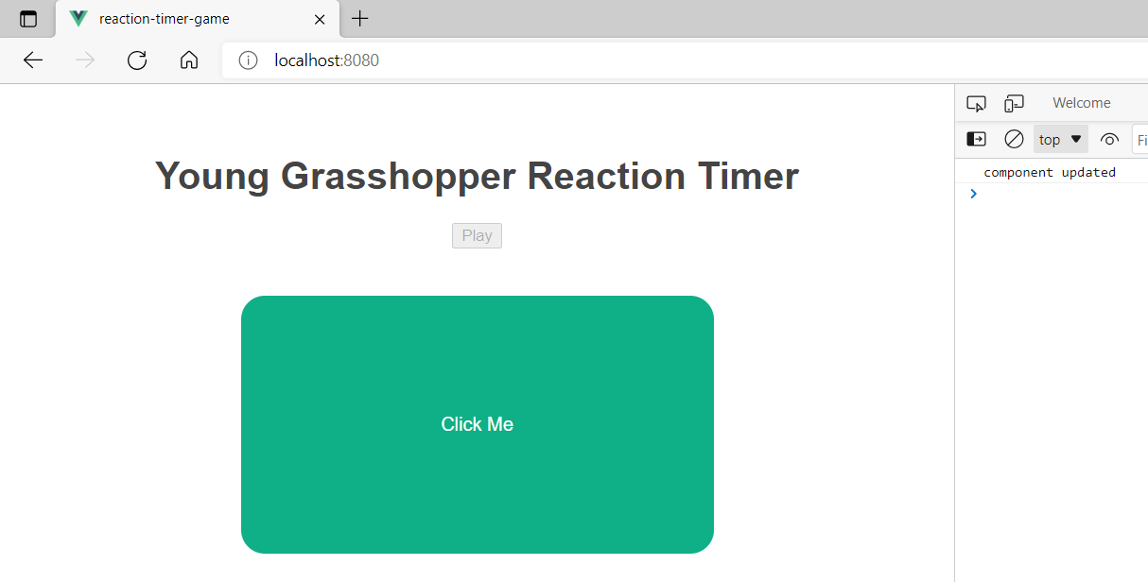

**Step 4:** In the **Block.vue** file, add the Lifecycle Hook unmounted and console log the text, “**unmounted**”. The text will be outputted as soon as the component is removed from the root component and no longer being displayed.

Look at the example below (**between line 28 to 32**):

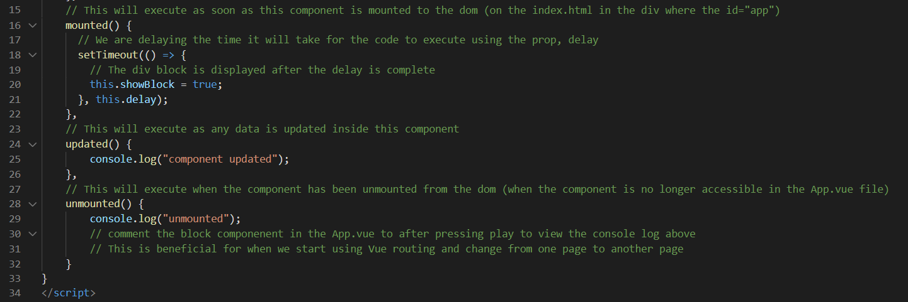

**Output:**

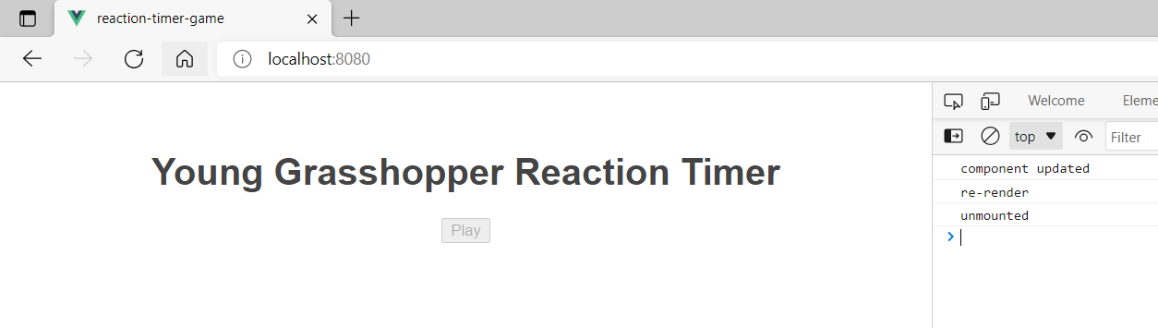

**You can view the code snippets from the** [**vue3-firebase-course**](https://github.com/younggrasshopperza/vue3-firebase-course) **repository under the Tutorial-22 branch**.